Immediate controllable global cooling with Climate Photocatalyst

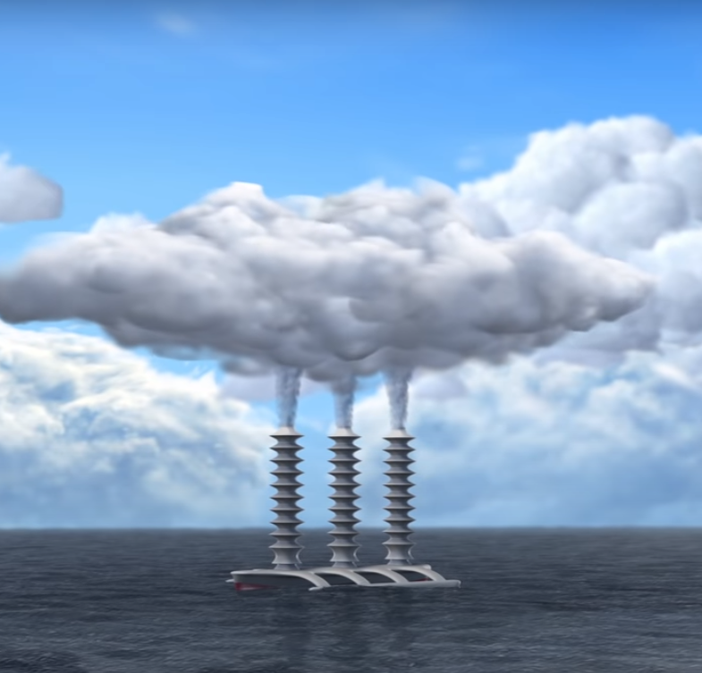
Clive Elsworth, Franz Oeste, Sep 2023

Contents
Summary 4
Introduction 4
Climate and policy predicament 4
New knowledge brings new possibilities. 5
List of abbreviations 6
Background 7
What is an aerosol? 7
Different Solar Radiation Management (SRM) proposals 7
What is driving global warming? 8
Greenhouse gas warming influences 8
Amplified warming from water vapour 11
Atmospheric sink mechanisms 11
Methane removal by naturally occurring iron salt aerosol 13
The cooling effects of clouds and haze 16
Clouds mainly trap heat in polar regions. 19
Risk of accelerated sea level rise and superstorms 20
The extent of cooling needed. 21
The effect of Net Zero without cooling 22
Proposed solution. 22
What is Climate Photocatalyst? 23
Aerosol particle formation and operation 24
Opportunities for cooling the climate. 26
Illustration of Climate Photocatalyst reducing radiative forcing. 26
Ice sheet collapse avoided? 28
Best locations to disperse the aerosol. 28
Dispersal techniques and platforms 30
Targeted use cases 33
Preserving ice sheets 33
Removing Arctic methane bursts. 34
Reducing hurricane and flood severities 35
Reducing wildfire intensities 35
Removing black carbon aerosol (BC) from the air. 36
Protecting coral reefs 36
Safety 37
Protecting the stratospheric ozone layer. 37
Toxicology 38
Comparison to Stratospheric Aerosol Injection (SAI) 38
Weakened methane sink from an SAI intervention. 39
Costs. 40
Cost Summary 40
Estimated material amounts from total required CCN 41
Feedstock costs 41
Cost of materials and fuel 42
Cost of reducing wildfires 42
Business Model 42
Next Steps. 43
International political cooperation needed. 43
Further tests needed. 43
Tests and development activities. 44
Conclusion 44
References 45

Summary
Climate Photocatalyst is one of several methods being proposed to stave off catastrophic climate change while net zero carbon emissions is achieved. The cost is estimated to be in the low 10s of $billions per year, possibly even under $10 billion per year.
It works by adding non-toxic microscopic particles to the existing sea spray, mineral dust, sulphuric acid, and other substances that already combine together with water vapour to form cooling clouds over the ocean. At the same time, it can be configured to remove methane from the air, by mimicking the part of the natural methane sink that is also driven by these substances in combination with sunshine.

Introduction

Climate and policy predicament
It is now not uncommon in some parts of the world for a whole month’s rainfall to arrive in just a few hours. Moreover, if the climate is allowed to continue warming in the coming decades, this year’s extreme weather events are likely to look tame by comparison. Meteorologists warn that as temperatures increase, the warming amplification of water vapour – itself a powerful greenhouse gas – will dwarf the warming influence of legacy greenhouse gas emissions. It’s the extreme heatwaves with high humidity that kill people and ecosystems. This year large swathes of coral reefs, which are important nurseries for fisheries, have died before even getting a chance to bleach (Ref). A recent study estimated the global cost of extreme weather events at $143 billion per year (Newman, 2023) [*check droughts]. That does not include the economic cost of long-term droughts and the spread of tropical diseases such as dengue fever. We could go on.
While it’s important to pursue Net Zero efforts, it’s also crucial to be aware that even Net Zero tomorrow would not stop the climate warming. The current warming influence, driven mainly by cumulative emissions, is now heating the oceans by an amount equivalent to around six Hiroshima bombs per second. If feedback mechanisms are considered, that puts another 10°C of warming in the pipeline (Hansen 2023), with 4°C likely by 2100 – a catastrophic outcome for human civilization.
Hansen’s climate predictions have been broadly correct since his Congressional deposition in the 1980s when he warned of the dangers of “delayed effects”. Those effects are now in operation as self-reinforcing feedback mechanisms, which are multiplying each other. The cornucopia of these mechanisms is also making the future speed of climate breakdown difficult to predict, even by the most expert climate scientists. In addition, the nature of self-reinforcing feedback means the conditions worsened by each day of delayed action are becoming more difficult to reverse.
The Net-Zero only policy advocated by the IPCC and adopted by policy makers writ large is based on climate modelling (MacDougal) that omitted important feedback mechanisms, such as polar ice loss. Those mechanisms were left out because they were considered too uncertain to model with sufficient accuracy. In contrast, Hansen’s 2023 paper is based on historical climate data based on corroborated proxies. Today’s insistence on the Net Zero only policy appears to be additionally fuelled by fears that a cooling intervention would disincentivise emissions reductions (Overshoot Commission). However, that is akin to refusing life-saving treatment to a dying heart attack victim on the grounds that it would disincentivise their adoption of a healthy lifestyle!
In the medium-term one of the effects of the Net-Zero only policy will be for mountain glaciers around the world to continue shrinking. That risks widespread loss of irrigation leading to loss of agricultural production, famines, mass migration, and conflict. Unless climate change is addressed effectively it will be a one-way process to disaster, like failing to extinguish a house fire before the whole house is destroyed.

New knowledge brings new possibilities.
Clouds already provide a powerful cooling effect by reflecting away around 23% of the sun’s energy. According to a NASA article (Ref) without clouds ocean temperatures would be around 5ºC warmer than today. In addition, it has long been known that the sulphate content of air pollution has been increasing the cooling effect of clouds since the industrial revolution. That increased cooling influence has been masking some of the greenhouse warming influence. However, as pollution is removed around the world global warming is accelerating.
That and other knowledge has led many scientists around the world to say (at least privately) that the march towards global climate disaster is entirely unnecessary. For example, Alan Gadian, Prof of Meteorology, Leeds University said in a presentation to The Healthy Planet Action Coalition (HPAC, 5 Oct 23): “We now know from the warming unleashed from the removal of sulphate pollution that the cooling influence of clouds can be increased to induce another ice age” *[get permission from Alan].
In this paper we propose that as air pollution is cleaned up, the resulting lost cloud reflectivity could be safely replaced and augmented with benign aerosols. The effect would be to cool the world’s oceans and restore more clement weather patterns. One study has suggested that carefully targeted increases of cloud reflectivity could not only restore rainfall patterns but further improve them (Ref Norwegian study).
Climate Photocatalyst is a proposed family of aerosol formulations that is additionally designed to remove methane and other powerful warming agents from the air, adding to the cooling effect. However, even if only cloud reflectivity were to be increased – at sufficient scale in the appropriate places – the effect would be an immediate reversal of the current warming trend. That would buy more time for the also crucially important goal of Net Zero emissions to be achieved globally. In the meantime, it would save countless lives, infrastructure, money, ecosystems, and species from extinction.

List of abbreviations
AI Artificial Intelligence
AMOC Atlantic meridional overturning circulation
BC Black Carbon (the soot and char content of smoke)
CCN Cloud condensation nuclei
CO₂e Carbon dioxide equivalent, a measure of greenhouse gas forcing.
ºCl Chlorine radical (single uncharged chlorine atom)
DMS Dimethyl sulphide (emitted by phytoplankton, oxidises to sulphur dioxide in the air, then further to sulfuric acid)
EEI Earth’s energy imbalance
ERF Effective radiative forcing
Fe Iron; FeCl₃ - ferric chloride; FeCl₂ - ferrous chloride.
GWP Global warming potential, expressed as a multiple of the GWP of CO₂
H₂O₂ Hydrogen peroxide
HNLC High Nutrient Low Chlorophyl (usually means areas of the ocean that are high in nutrients except iron micronutrient)
IPCC International Panel on Climate Change
ISA Iron Salt Aerosol
MCB Marine Cloud Brightening
ºOH Hydroxyl radical
ppb Parts per billion; ppm - Parts per million; (in this document as gas molecule mixtures).
Si Silicon; Si(OH)₄ - silicon hydroxide/silicic acid (weak acid); SiCl₄ - silicon tetrachloride
Ti Titanium; TiO₂(OH)₂ - titanium peroxohydroxide; TiCl₄ - titanium tetrachloride
SAI Stratospheric Aerosol Injection
SLCFs Short Lived Climate Forcers (mainly methane, tropospheric ozone, black carbon aerosol)
SRM Solar Radiation Management
UAV Unmanned Aerial Vehicle (drone)
UV Ultraviolet (light); UVC - the less energetic UV component prevalent in the troposphere.
VOC Volatile organic compound (e.g. methane, ethane, methyl-halides, vinyl-chloride, etc.)

Background
The scientific disciplines of atmospheric chemistry and cloud microphysics are relatively new and unfamiliar to most scientists. However, both are highly relevant to Climate Photocatalyst. This document introduces these topics at the level of high school science, to make the material as accessible as possible. References are provided for those wishing to study further.
This section begins with a brief introduction to aerosols and a short note on types of solar radiation management (SRM). It then introduces the main influences that are variously warming and cooling the climate. The main short-lived powerful warming agents are then described, followed by the natural chemistry that removes them from the atmosphere, giving them their short lives. Following that, the cooling effects of haze and clouds are briefly described, with an overview of how they form in the air and then subsequently either burn off in the sun or rain out. Then we explain how avoidance of catastrophic climate tipping points would require Effective Radiative Forcing to be reduced back to zero or below. Finally, we cite works that explain how the effect of Net Zero without any cooling intervention would likely be collapse of civilization.

What is an aerosol?
An aerosol is a suspension of fine solid particles or liquid droplets in air (strictly, any gas). The air already naturally contains aerosol particles that are so small that they can remain airborne for weeks without sinking to the ground. This includes pollen, bacteria/viruses, sea salt, ammonium salts, sulphuric acid, mineral dust particles, and particles that form from vapours emitted by forests and plants in general, seaweed and phytoplankton. For example, isoprene vapour emitted by vegetation is a major precursor of aerosol particles (Claeys 2004). Of course, the air also contains particles from human activities such as smoke, and particles that form from human emitted vapours such as industrial emissions and vapours from household cleaning products. Most airborne particles are removed from the air by raining or snowing out (Ardon-Dryer 2015). Only the largest particles sediment as dust. Cloud droplets and haze particles are also examples of aerosols.

Different Solar Radiation Management (SRM) proposals
Solar radiation management (SRM) cooling technologies that involve injecting aerosols into the atmosphere are controversial. However, there is a big difference between the effects of injecting aerosols into the stratosphere and troposphere. Unfortunately, since both schemes come under the general heading of SRM they are often conflated. Given that the side-effects of stratospheric aerosol injection (SAI) are feared by many scientists, both schemes then tend to get rejected together.
Clouds have been forming continuously in the troposphere for billions of years and depend on naturally occurring aerosols to do so. Further, the formation and evolution of clouds in the air has been altered by humans ever since they began lighting fires. We regard learning how to safely increase cloud cooling effects and to reduce extreme flooding as worthwhile endeavours.

What is driving global warming?
The main warming influence is greenhouse gases that have accumulated in the atmosphere. However, a large cooling influence is also provided by increased cloud reflectivity resulting from certain aspects of pollution. Each warming/cooling influence is quantified by climate scientists in units of W/m², which is a measure of energy flux per unit area of the Earth, also called radiative forcing. The net radiative forcing of all the influences combined is given by the IPCC as the Effective Radiative Forcing.
For the past 6000 years up to the pre-industrial era Earth’s warming influences exactly matched its cooling influences. During that time the result was unchanging sea level and stable ice sheets. The warming and cooling influences can be likened to changes to household income and expenditure. If total income exactly matches total expenditure the household bank balance remains static. If income increases permanently and expenditure also increases but by less, the bank balance starts going up. The human impact on the climate has been to increase both warming and cooling influences, but the increased cooling influences are not large enough to offset the increased warming influences. That is why the Earth is warming.
Figure 1 below is an IPCC chart that shows how the warming/cooling influences on the climate have changed since 1750. In the diagram, bars to the right of the vertical zero line are warming influences that are at an increased level. Cooling influences (Aerosols as additional cloud and haze cooling caused by air pollution) appear to the left of the zero line. These cooling influences are also at an increased level, but not enough to offset the warming increases. The overall change is an increase in Effective radiative forcing of 2.9 W/m².
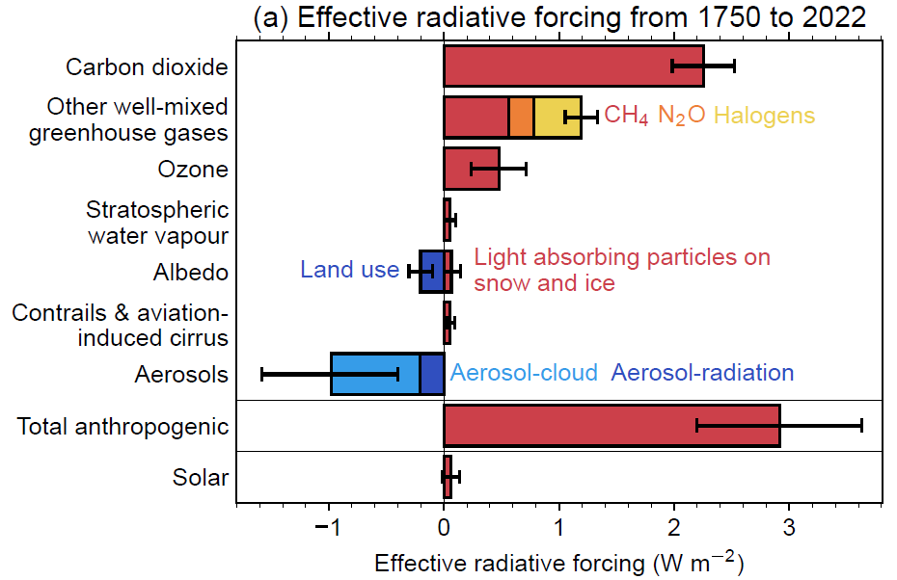
Figure 1 - Global warming and cooling influences (Forster, 2022).

Greenhouse gas warming influences
The main greenhouse warming influence is carbon dioxide, at over 2 W/m². Figure 2 below shows how, despite intense political efforts to reduce CO₂ emissions and now to remove CO₂ from the atmosphere, atmospheric CO₂ concentration keeps rising inexorably. There has been no discernible effect from any of the numerous COP events (Conference of the Parties), renewables transitions or any other intervention. The most noticeable flattening happened during the economic recession of the early 1990s. The massive Pinatubo eruption in 1991 may also have played a part in that period of atmospheric CO₂ flattening in various ways, including possibly diffuse ocean fertilisation.
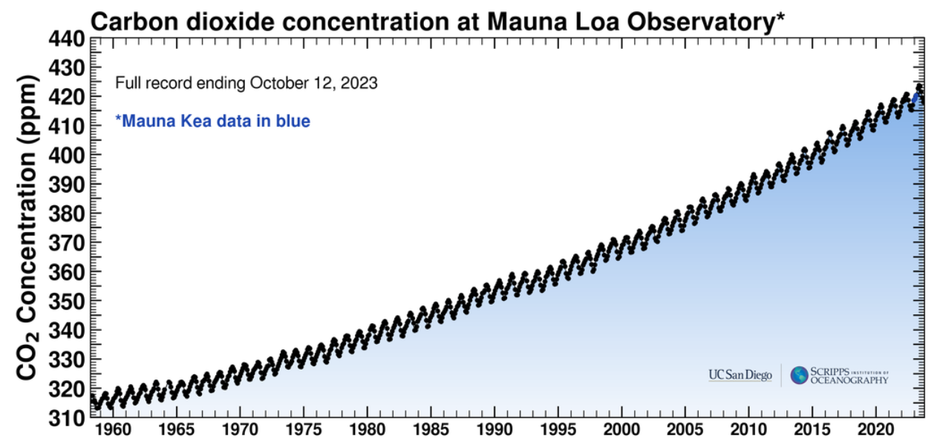
Figure 2 - Atmospheric CO₂ concentration since 1960 (Ref).
In the coming decades we expect competitively priced advanced nuclear power to begin displacing CO₂ emissions from power generation, industrial process heat, and district heating (for example, the MoltexFLEX reactor). However, as stated earlier even a best-case scenario of Net Zero would not reverse today’s damaging climate feedback mechanisms. That is because of the warming effect of accumulated legacy greenhouse gas emissions, and the large amount of extra heat now stored in the oceans (Ref Hansen).

Short-lived powerful climate warming influences
The main short lived powerful warming agents are methane, tropospheric ozone, black carbon aerosol (smoke), and some halogenated gases. In scientific literature these powerful warming agents are termed Short Lived Climate Forcers (SLCFs). Table 1 below lists the main SLCFs and their fraction of radiative forcing compared to CO₂.
Table 1
Short-lived climate forcers (SLCF) | Instantaneous Global Warming Potential (GWP) | Radiative forcing in 2022 | Fraction of CO₂ radiative forcing | Reference
Methane | 120 | ? | 30% | ?
Black Carbon Aerosol | 2000 | ? |  | Hansen 2003?
Tropospheric Ozone | ? | ? |  | ?
Total:

The instantaneous GWP is a measure of the warming influence per ton of substance compared to CO₂ while it remains resident in the air. Economists prefer to specify the warming influence of SLCFs over a specified time period such as 20 or 100 years. However, these time-dependent metrics vary with atmospheric conditions. For example, during the long glacial periods of the past million years these substances are thought to have been shorter-lived in the air because the oxidative capacity of the troposphere was stronger. If climate interventions that similarly strengthen the troposphere’s oxidative capacity become enacted, the average lifetimes of SLCFs will get shorter again, which means the standardised 20-year or 100-year metrics will become outdated and inaccurate. To calculate the current radiative forcing of these warming agents irrespective of tropospheric oxidative capacity the magnitudes of their average atmospheric concentration and instantaneous warming potential are needed.

Methane
As shown in Table 1 above, methane contributes the main warming influence of the SLCFs. Today’s methane concentration of over 2000 ppb is nearly three times the pre-industrial level of around 700 ppb. As a result, methane alone is now inducing almost a third the warming influence of CO₂. Methane is emitted from numerous sources, mainly wetlands, agriculture, and millions of active and disused oil/gas wells and coalmines around the world [Ref], even though many of these are supposedly capped.
A future potentially very large source of methane also exists as methane hydrate deposits in continental shelf seas (See Figure 3 below). An estimated X Gt of methane exists in these deposits. Fortunately, the current emission rate to the atmosphere is estimated to be only 2 – 6 Mt CH₄ / yr (less than 1% of total methane emissions around 600 Mt/yr). However, this can be expected to increase as the seas above them warm up. Most of the methane released into seawater more than around 10 m deep [check] is consumed by microbes. However, the CO₂ byproduct acidifies the ocean and reduces its capacity to absorb more atmospheric CO₂.
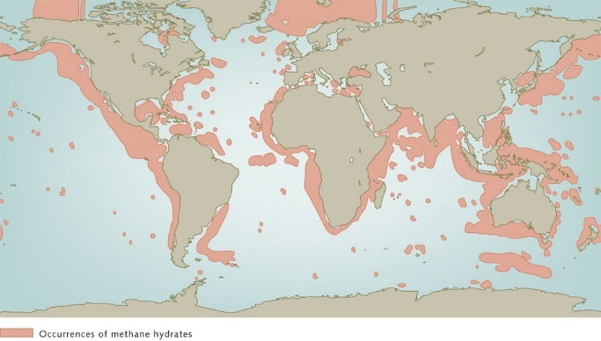
Figure 3 - Methane hydrates in continental shelf seabeds (Ref World Ocean Review).

[Mention Baltic Sea methane emissions and Brazil?? - Ref]
Another risk is that of major Arctic methane bursts. The risk is of increasingly warmer waters flowing into in shallow Arctic seas, melting the permafrost in seabeds that covers huge frozen methane hydrate deposits (Shakhova). This permafrost layer that lies beneath the sediments acts as a barrier that prevents warm water flowing into the methane hydrate deposits.
The total amount of methane in Arctic subsea deposits (around X Gt) would quickly overwhelm the climate if released all at once. Fortunately, total emissions from these areas are also still a small fraction of total methane emissions (about X %), but the continually rising temperature of waters entering these seas is melting holes in the permafrost layer.
Over the past 20 years Shakhova and her colleagues have observed increasing amounts of methane bubbling out of shallow Arctic seas, mainly the Laptev and East Siberian seas. Increasing methane concentrations have also been measured by NOAA in Barrow Alaska, reaching 2400 ppb in August 2023. Peak measurements in late summer appear to be increasing exponentially. (See Figure 4 below).
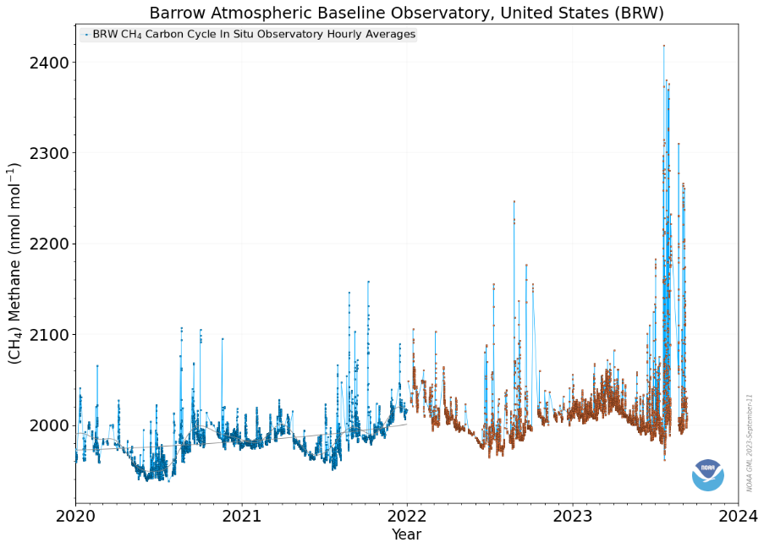
Figure 4

Tropospheric ozone
Ozone exists naturally in both the stratosphere and troposphere. Ozone in the stratosphere absorbs harmful UV. In the troposphere naturally low levels of ozone contribute an important part of the oxidative photochemistry that continually removes SLFCs such as methane (see below: Photochemistry of the tropospheric oxidative sink.). However, large concentrations of ozone can build up in the troposphere by interaction of methane and other pollution with sunshine (Ref). These high tropospheric ozone concentrations add a significant climate warming influence. At ground level they also cause respiratory problems and can damage crops.

Black carbon aerosol
Black carbon aerosol (BC) is also a powerful greenhouse warming agent. As BC particles warm up in the sun they rise up by convection to the stratosphere and then migrate towards the polar regions (Brewer Dobson). BC also induces secondary warming effects. For example, most BC is produced in the northern hemisphere, some of which forms an Artic haze that prevents heat escaping during polar winters (See Table 2 - The cooling/warming effect of clouds, p19). In the winter, BC sediments in snow, which darkens it, increasing snow/ice melt rates during melting seasons.

Amplified warming from water vapour
Water vapour is not included in the climate forcers of Figure 1, nevertheless it operates as a greenhouse gas that amplifies the warming effect of the other forcing agents combined, because their warming influence enables the air to hold more water vapour. The Clausius Clapeyron principle states that the water vapour pressure in the air increases by 7% for each 1°C rise in temperature (O’Gorman 2010). This represents another self-reinforcing feedback mechanism warming the Earth.

Atmospheric sink mechanisms
Most of the Short-Lived Climate Forcers (SLCFs) are short-lived because they are oxidable, which means they are continuously destroyed by atmospheric oxidative processes, also called sinks.
The chemical nature of most SLCFs makes them easier than carbon dioxide to remove from the atmosphere artificially. That is because the oxidative capacity of the troposphere over the ocean could be enhanced by mimicking some of the naturally occurring chemical mechanisms that constitute these sinks. Increasing sink capacities would shorten the average residence time of most SLCFs in the air. That would reduce their atmospheric concentration, thereby reducing their radiative forcings.

Photochemistry of the tropospheric oxidative sink.
Most oxidation of SLCFs is induced by interaction with airborne highly oxidative chemical radicals. The two main radicals involved are ºOH (hydroxyl), and ºCl (single uncharged chlorine atom). (The º denotes a single unpaired electron in a nearly complete electron shell. That is what makes these radicals highly oxidative.) The ºOH radical has been called “the detergent of the atmosphere” (Crutzen) owing to its large-scale removal of SLCFs.
ºOH and ºCl radicals remove from the air mainly methane, ozone, and some halogenated gases. They also ‘age’ BC particles making them more easily rained out.
The following simplified chemical equations show how oxidative radicals are formed naturally in the air, and how they oxidise methane and other SLCFs.

How OH radicals are produced in the air.
ºOH radicals are produced naturally throughout the atmosphere, mainly by interaction of light (hv) with ozone (O₃):
O₃ + H₂O + hv O₂ + 2ºOH

Methane removal
We are all familiar with methane burning in a flame as natural gas, but in low concentration, methane molecules are somewhat inert. In low concentration they are only removed (oxidized) when they encounter the oxidative power of one of these radicals. Without these radicals occurring naturally in the air, the concentration of atmospheric methane could be thousands of times higher or more.

How OH radicals remove atmospheric methane.
ºOH radical oxidation of methane produces water and CO₂ as follows:

CH₄ + ºOH ºCH₃ + H₂O
ºCH₃ is unstable and becomes oxidised by oxygen to CO₂ and H₂O.

How Cl radicals remove atmospheric methane.

CH₄ + ºCl ºCH₃ + HCl

In humid air ºCl radicals can remove methane up to around 250 times faster than ºOH radicals. This is because:
- The reaction rate of methane removal by chlorine radicals is around 16 times faster than by ºOH radicals.
- Humidity impedes the rate of methane removal by ºOH radicals also up to 16 times, whereas the reaction rate of chlorine radicals is unaffected by humidity.
For that reason, a relatively small amount of mineral dust has been found removing significant amounts of methane from the atmosphere.

Methane removal by naturally occurring iron salt aerosol
ºCl radicals are produced in the marine boundary layer by naturally occurring iron salt aerosol. The iron salt (FeCl₃) forms from the iron contained in mineral dust, sea salt aerosol and airborne acidic substances. A large measure of these acidic substances occurs naturally, the remainder comes from shipping emissions and other pollution.

Example of natural ferric chloride formation
The reaction below is of iron oxide (haematite) reacting with the salt from sea spray aerosol and sulfuric acid to produce ferric chloride.
Fe₂O₃ + 6NaCl + 3H₂SO₄ 2FeCl₃ + 3Na₂SO₄ + 3H₂O
Fe₂O₃ + 6NaCl + 6HNO₃ 2FeCl₃ + 6NaNO₃ + 3H₂O
Marine aerosol particles tend to be highly acidic because acid gases such as HCl, HNO₃ and H2SO₄ occur naturally in the oxic environment, and dissolve easily into the aqueous coats of particles (Ref from Ref doc).

Figure 5 below shows how methane oxidation by Cl radicals occurs in a photocatalytic cycle, photo-catalyzed by the ferric chloride that has formed in the aqueous coat of a mineral dust particle (ISA). In the ISA cycle shown in Figure 5 below, photon absorption by FeCl₃ causes ºCl radicals to be expelled into the air. After oxidising methane, the Cl radical is bound to hydrogen as HCl gas. Being hydrophilic, HCl is then reabsorbed back into the particle where it restores FeCl₂ back to FeCl₃, driven by atmospheric oxidants such as oxygen.

Hydrophobic vs hydrophilic vs hygroscopic
Hydrophobic substances repel water, whereas hydrophilic substances attract water and dissolve easily into it. The term hygroscopic is usually used for particles that attract moisture from the air but can later evaporate it away again.

The methane removal effect of this chemical cycle was confirmed in 2023 Byfield Measurement in the Caribbean and Cape Verde Islands (Van Herpen 2023). The airborne mineral dust was picked up by Saharan winds and blown over the ocean. The photo-catalytic effect of ISA has also been measured in laboratories since 2014 (Ref Wittmer, Zetzche, Johnson). The phenomenon was first predicted by Franz Oeste in 1999 [check].

Figure 5 - How iron salt aerosol photocatalyzes methane removal by Cl radicals in a photocatalytic cycle.
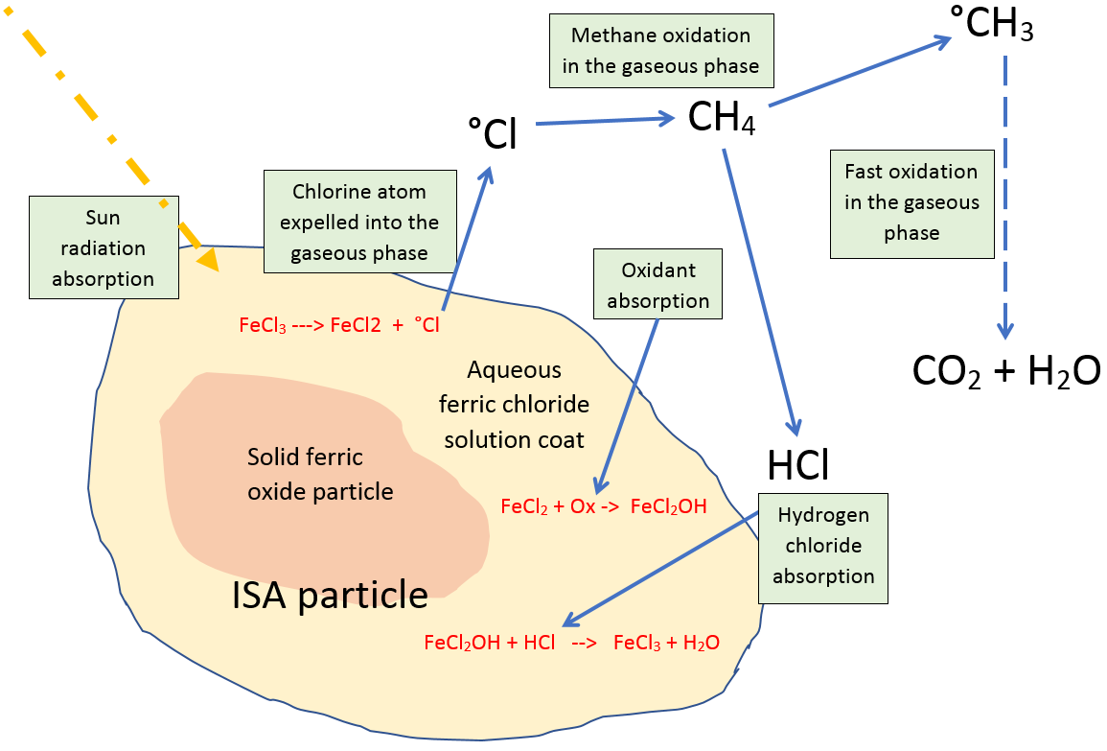

Other SLCF photochemistry

Chloromethane is also oxidised by ºCl radicals.

CH₃Cl + ºCl ºCH₂Cl + HCl

ºCH₂Cl is oxidised by O₂ to HCl, CO₂ and H₂O in complex ways.

How Cl radicals remove ozone

°Cl + O₃ °ClO + O₂
°ClO + O₃ °Cl + 2O₂
Net effect on ozone: 2O₃ 3O₂

N.B. Neither mineral dust aerosol nor sea spray aerosol reach the stratosphere because they always get rained out of the troposphere (See p37).

BC aerosol particles ‘age’ in the air, making them rain out.
Oxidative radicals also help to prevent BC from reaching the stratosphere by removing them from the troposphere. That is because oxidative radicals add oxygen functional groups to the graphene layers and other carbon structures that make up BC particles. Oxygen functional groups transform the nature of BC particles from water-repelling (hydrophobic) to water-attracting (hygroscopic). These ‘aged’ hygroscopic particles operate as CCN, which makes them rain out within a few days or weeks. See later: Cloud Condensation Nuclei (CCN).

In clouds the Fenton reaction is also catalyzed by ISA particles to produce ºCl radicals.
The Fenton reaction involves iron with hydrogen peroxide (Ref). The following simplified reactions indicate the result:

H₂O₂ + hv 2 °OH

°OH + HCl H₂O + °Cl

Even though ºCl radicals oxidise methane faster than ºOH radicals, ºOH radicals are a stronger oxidant than ºCl radicals. Therefore, as in the Fenton reaction above, ºOH radicals oxidise chloride ions to produce ºCl radicals.

ISA efficiency is optimal in dry sunny conditions.
ISA photocatalysis produces ºCl radicals most rapidly below pH2 (Ref Wittmer, Zetzche). In dry sunny weather clouds tend to burn off, leaving particle coats more concentrated and acidic. This enables methane to be removed at maximum speed.

For more detailed descriptions see document Section 5 Atmospheric Effects (Oeste, Elsworth, [date]).

Nitrate also produces oxidative radicals by photolysis.
During the main Covid lockdown when flights were grounded and transportation generally diminished, the methane sink was weakened in places (Ref Stevenson). This was not a surprise to us because when ISA particles were tested in the presence of NOx, ºCl radical production by ISA increased seven-fold (Ref Wittmer, Zetzche). NOx is a family of nitrogen gases produced by lightning and combustion engines. It is absorbed by water to produce nitric acid. NOx can also be produced by a plasma arc.

The cooling effects of clouds and haze
On average, clouds reflect away 74 W/m² of the sun’s energy globally (Ref). The cooling effect of clouds thus dwarfs even the current Effective Radiative Forcing of 2.9 W/m². The total energy entering the Earth is 340 W/m², which means the reflection of 74W/m² by clouds can be understood as 23% of the sun’s energy never even reaching ground level. However, clouds also trap heat (see p19). That means for each 1 W/m² of overall cloud cooling, an increase of more than 1 W/m² cloud reflectivity is needed.
As mentioned earlier, the increased reflective aerosol in the air resulting from air pollution has been elevating the cooling effect of clouds for hundreds of years, but that is now declining. For example, the removal of SO₂ emissions from shipping in recent years has increased Effective radiative forcing, by reducing total cloud negative forcing. The loss of SO₂ emissions from shipping has thus accelerated the rising trend of already rising sea surface temperatures, especially along shipping corridors (Ref). The lack of suitable satellite measuring equipment has up to now left climate scientists unsure of the extent of the extra aerosol cooling produced by pollution. However, now that that pollution has been significantly reduced and the energy imbalance has increased, the additional cooling influence induced by pollution is now known to be at the higher end of the error bars shown on Figure 1 p8.
Clouds have another cooling effect: The removal of water vapour from the air during the day by clouds adds an additional cooling effect, because water vapour itself acts as a greenhouse gas. Another way to understand this principle is to think of every cloud droplet representing water that has transformed from being a warming influence (sun heat absorption by water vapour) to a cooling influence (sun heat reflectivity by a cloud droplet).

The glacial periods were cooled by dust.
Ice cores indicate that the glacial periods of the last million years were up to 10 times dustier than today. That dustiness would have caused a large cooling effect, both by increasing cloud reflectivity and by photo-catalysing more atmospheric methane oxidation (Oeste 2017).

Haze can provide as much cooling as brightened clouds.
Early articles on Marine Cloud Brightening (MCB) proposed that the only way to achieve a worthwhile level of cooling was by brightening certain types of cloud commonly found in certain ocean areas (Ref Hayward et al). However, more recent work indicated that long-lived haze could add a similar level of cooling as cloud brightening (Ref Ahlm). Haze has a comparable cooling effect because it has a prolonged residence time in the air, which offsets the fact that its instantaneous cooling effect is usually weaker than cloud brightening.

Cloud Condensation Nuclei (CCN)
Cloud droplets form over aerosol particles that are often a mixture of substances, including mineral dust, pollen, sea salt, and sulfuric acid. Particles that initiate this process are known as cloud condensation nuclei (CCN).
CCN aerosol particles are microscopic, with diameters typically sub-micron in diameter, i.e. hundreds of times smaller than the width of a human hair. Thus, CCN particles do not fall out of the air, because air friction and turbulence move them around with much more force than the force of gravity. In other words, they remain mixed in the air like cream mixed in coffee. CCN aerosol particles only leave the air (sedimentation) by forming cloud droplets that later rain out (or precipitate as snow or hail).

Aitken, Accumulation, and course mode particles
[explain the modes plus pic – do in separate sheet]

Haze formation and its cooling effect
[replace with something better, with a Ref] The condensation of airborne water vapour onto each particle releases latent heat of condensation, which drives the particles upwards. The marine boundary layer is typically turbulent, so haze quickly spreads and disperses in the air. The haze then adds a cooling influence to the oceans, reducing the amount of further water vapour evaporated from the resulting shaded sea surface. That reduces the humidity of air that otherwise releases latent heat when it flows into higher latitudes.
Mention hygroscopic particles adding haze.

Cloud formation
Cloud droplets form on CCN particles at an altitude where the air is supersaturated, meaning the relative humidity exceeds 100% (also called the dew point). Under these conditions water vapour continually condenses out of the air onto particles until relative humidity falls below 100%.
Cloud formation and evolution involves complex cloud microphysics and is currently an area of intense research.
However, quite clearly the availability of hygroscopic CCN has an effect on cloud fraction. Figure 6 is a comparison from NASA of average monthly cloud albedo [check] versus ocean chlorophyll that shows a close correlation. We suggest that clouds are tending to form where there is abundant or at least more hygroscopic CCN, produced by an abundance of sulphuric acid, resulting from phytoplankton emissions.

How phytoplankton induce cloud formation
Phytoplankton emit dimethyl sulphide (DMS), which oxidises in the air to form sulfuric acid (Ref). Sulfuric acid becomes absorbed into mineral dust/sea salt aerosol particles, making them more hygroscopic, which makes them act as more effective CCN (Ref). (i.e phytoplankton produce the same substance now removed from shipping emissions.) Phytoplankton have been declining in the ocean by an estimated 1% / yr (Ref). The loss of sulfuric acid aerosol particularly in the north Atlantic marine boundary layer may be contributing to accelerating atmospheric methane levels, owing to reduced removal of methane by mineral dust photocatalysis (see p14).
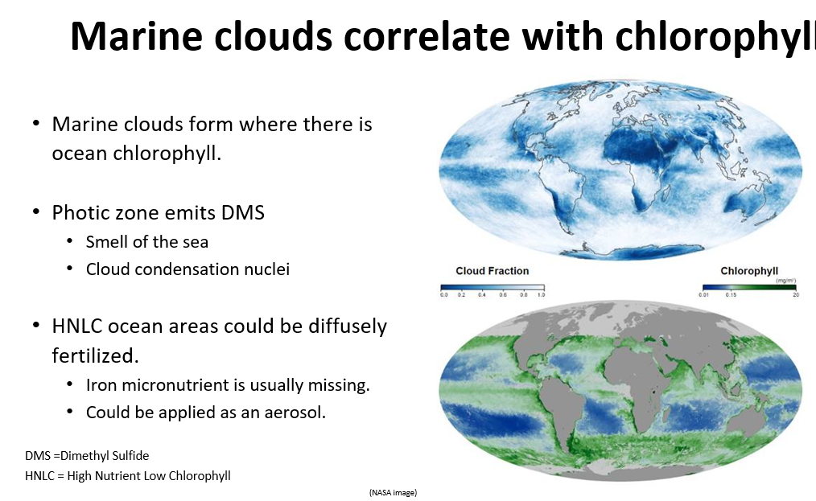
Figure 6 - Marine clouds correlate with chlorophyll.

Since the air always contains CCN, clouds always form in sufficiently supersaturated air. That means additional clouds cannot easily be formed artificially. However, scope exists for increasing cloud reflectivity by adding CCN to existing clouds (see below).

Cloud brightening - to increase cloud albedo (reflectivity).
Like any surface, bright white clouds reflect away more light than dark clouds. Clouds that form where there is a high concentration of CCN are brighter, because they consist of a larger number of smaller droplets, which increases the total surface area reflecting light. This phenomenon, known as the Twomey effect is illustrated below with glass spheres of two different sizes, showing the smaller spheres looking whiter than the larger spheres:
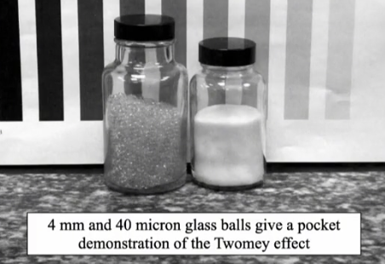
If more CCN are introduced into an existing cloud, the water content of its existing droplets gets shared out among all the new and old nucleation particles (by continual evaporation and condensation), making a larger number of smaller droplets. Brightened clouds provide cooling in two ways. Firstly, they reflect away more heat from the sun. Secondly, they last longer before raining out (Ref Albrecht).
[*Give an example of typical cloud CCN droplet number - e.g. 200/cm³. An increase of 10% causes an increase of ? Albedo.]

Cloud burn-off
Describe cloud ‘burn off’ and how BC increases this.

Cloud rainout
Describe accumulation, and coarse modes etc.]

Clouds mainly trap heat in polar regions.
Clouds both reflect away sunshine and trap heat beneath them. However, as a general rule the closer clouds are to the equator the stronger is their overall cooling effect. In the polar regions, clouds induce a warming effect for most of the year, and only provide an overall cooling effect there for around two months in mid-summer (Ref Shupe). Table 2 below provides a rough guide to the warming/cooling effect of clouds on polar/sub-polar regions at different times of the year (Refs).
Table 2 - The cooling/warming effect of clouds
 | Altitude | Low - Stratocumulus |  |  | High - Cirrus
 | Latitude | Polar regions | Elsewhere | Whole globe
Season | Mid-summer | Cooling | Cooling | Warming
Season | Rest of year | Warming | Cooling | Warming

Risk of accelerated sea level rise and superstorms
All ice sheets around the world are losing ice (decadally at least), driven by numerous self-reinforcing feedback mechanisms. Unstable ice sheets are known to have entered periods of rapid collapse in the past. If that happens again in the coming decades the resulting sea level rise would render entire metropolises near sea level uninhabitable and destroy millions of hectares of arable land by salination [check, Ref].
Even before then, according to veteran climate scientist Jim Hansen, rapid polar ice melt would cause devastating superstorms to become more frequent and “All hell breaks loose” (Ref Storms book). Superstorms are initiated by sharp air temperature gradients, which for millennia have been avoided by ocean circulation patterns that work towards equalising temperatures around the planet. The Gulfstream is not at risk since that is driven by the Coriolis force. However, the Atlantic Meridional Overturning Circulation (AMOC) is becoming increasingly threatened. A healthy AMOC is driven in the Arctic by the sinking of cold dense saline water that arrives in currents from lower latitudes. But loss of Arctic ice adds fresh water into the sea, reducing the density differences, thereby inhibiting the cold sinking process. The collapse of AMOC would accelerate the warming of lower latitudes, making sharper air temperature gradients more prevalent in Atlantic weather systems. It would also reduce deep ocean oxygenation, and nutrient upwelling, threatening fisheries.

Past AMOC collapses
It appears that the sharp temperature gradients induced in the weather by previous AMOC collapses could have caused superstorms that were so strong that they lifted boulders several metres wide out of the sea onto coastlines (Hansen, 2009). The last time the AMOC collapsed looks to have been around 13,000 years ago, as the last glacial period was ending (Keigwin, 2018). As the current polar ice melt rates continue to increase, the next AMOC collapse is modelled to occur sometime between 2025 and 2095 (Ditlevsen, 2023).

Figure 7 - Out of place on a cliff edge – a boulder that may have been deposited there by a superstorm.

What is melting the polar ice sheets?
Ice sheet melting rates are currently accelerating, owing in part to the unprecedented high temperature of sea water flowing into high latitudes. A portion of some ice sheets exists below sea level, which warm seawater is melting, destabilising the ice sheets from underneath.
Another mechanism is hindering the polar refreezing process each winter. As humid air flows from low to high latitudes it not only acts as a greenhouse gas that absorbs heat from the sun, but when it eventually condenses in higher latitudes it releases a great deal of latent heat there. This results in warmer waters and warmer, more humid air flowing into polar latitudes that thicken the cloud cover there. Thicker cloud cover traps more heat during polar winters, preventing it from escaping to space.
Further mechanisms accelerating ice sheet loss include:
- Increasingly torrential rain falling on the Greenland ice sheet, further destabilising it (Ref J Box),
- Discoloration of ice sheet surfaces by sedimented BC absorbing more heat from the sun during summer months, causing the ice to begin melting earlier. Melting ice itself naturally turns darker, absorbing more heat, which enables growth of algae and biofilms to further worsen the effect. Then as the meltwater drains away, it leaves dark material behind in concentrated form, as seen in Figure 8 below.
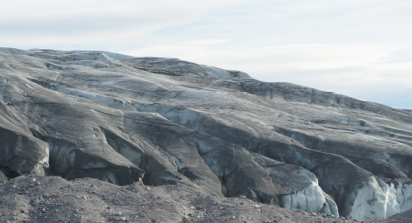
Figure 8 - Russell Glacier near Kangerlussuaq, Greenland on Aug 1st 2019 (Courtesy, Peter Wadhams)

After a visit to Greenland in 2019 Peter Wadhams said parts of the ice sheet “resembled mud”.

The extent of cooling needed.
If today’s warming could somehow be stopped, the oceans at their current temperature would continue melting the ice sheets towards their tipping points of collapse. If West Antarctica and Greenland are to be prevented from collapsing, ocean temperatures may need to be reduced, to below preindustrial. That is because these ice sheets have both passed their point of no return (or Greenland will do so soon if it hasn’t already). Air temperature generally decreases with altitude (by around 1°C per km [check] (Ref)). Therefore, ice sheets pass their tipping point when their surface descends to the point that the air at that altitude is warm enough to ‘tip’ them increasingly towards melting collapse.
To cool the oceans below pre-industrial temperatures would require effective radiative forcing to be reduced below zero, although that would take many decades. That is because their total heat capacity is so huge. Achieving that would most likely require a significant increase of cloud and haze reflectivity even if, for example, atmospheric concentrations of methane and other SLCFs could be halved. That is because CO₂ is proving so difficult to both remove and stop emitting that its strong warming influence is likely to remain for decades into the future. Over the long-term a cooling intervention by use of aerosols would only work if total greenhouse gas forcing stops increasing. Therefore, the sooner Net Zero can be achieved the less drastic those cooling interventions will need to be to reverse the melting trend.

The effect of Net Zero without cooling
Today’s policy of achieving Net Zero emissions within a few decades without any cooling effort would likely be the collapse of civilization. It is based on climate modelling from which important feedback mechanisms were omitted (Ref McDougall 2020). Hansen’s Global warming in the pipeline paper (Hansen 2023) calculates that a doubling of CO₂e will eventually lead to a 10°C rise in global average temperature, i.e. utterly catastrophic for human civilization. Given that the current greenhouse gas forcing is already about double the pre-industrial level, a 10°C rise is already assured without a cooling intervention. Even a rise of 3°C would gravely threaten civilization in most countries, and on current trends that temperature is due well before 2100. In 20?? MIT predicted the collapse of civilization by 2045? (Ref). This year (Ref 2023) the MIT group announced that current climate conditions are already ahead of that schedule.

Proposed solution.
Climate Photocatalyst is a proposed aerosol that could be used to provide nature-based, large-scale, low-cost powerful planetary cooling. (See Costs section, p40). It employs the same physical and chemical processes that have continuously provided cooling influences for billions of years. As mentioned earlier, the dusty conditions of the glacial periods provided a strong cooling influence [check], albeit less efficiently than Climate Photocatalyst would do. All Climate Photocatalyst processes operate exclusively in the troposphere and biosphere. Additionally, its removal of ozone destroyers that otherwise drift up to the stratosphere would help the stratosphere to recover a healthy ozone layer (see p37). Climate Photocatalyst is potentially therefore a very important tool that could safely delay or even reverse the onset of climate tipping points as described earlier [*check].
Climate Photocatalyst provides cooling influences in two main ways. It:
- Introduces a long-lasting reflective haze into the air that later brightens clouds.
- Speeds up the natural removal from the air of powerful greenhouse gases such as methane and other SLCFs.

A significantly large increase to Earth’s albedo alone could restore global ocean temperatures, albeit over decades (and depending on above caveats). The addition of haze to low latitude ocean areas would reduce total evaporation, delivering drier air and cooler waters into high latitudes.
As mentioned on p11, one of the major effects of climate change has been to add water vapour to the air. This is amplifying the warming trend and worsening flood events. Climate Photocatalyst forms a haze that removes water vapour from the air, enabling the water to spend longer reflecting sunshine away before raining out. This has a cooling effect that reduces seawater evaporation, reducing both humidity and further warming in a self-reinforcing feedback mechanism.
Climate Photocatalyst is not high-tech. The main proposal consists of non-toxic nano-sized aerosol particles produced by a combination of chemistry procedures known to industry for decades. Like naturally occurring aerosols it:
- Leverages water vapour, enabling it to condense as cloud droplets, providing a powerful cooling influence,
- Mimics natural oxidative processes in the troposphere, which remove SLCFs, such as methane,
- Typically rains out in about 3 to 10 days, depending on its altitude of dispersal and weather conditions.
If Climate Photocatalyst could be dispersed at scale in remote areas of the vast oceans it would be unseen by the world’s populations, other than for them to witness gradually declining temperatures, less severe weather events, improved water and food security, a halting of sea level rise, a declining risk of wildfires, coral reef recovery and global ecosystem recovery generally, such as forests.

What is Climate Photocatalyst?
Climate Photocatalyst is a family of related aerosol proposals with specific formulation options for different deployment and precursor scenarios. All options are low in toxicity, and most contain photosensitive compounds. When rained out, the particles flocculate (a procedure used in wastewater treatment) which makes them stick to other suspended material, removing any nano-particle hazard. The material then gradually degenerates to become clay mineral, which is inert.
[*Indicate the amount sedimenting in rainfall /m2 day. And mention negligible acidification, but the opposite - slightly raised pH from diffuse iron fertilisation (< 1mg Fe/m² day) over large areas and reduced ocean CO₂ outgassing.]
The most photosensitive formulation option involves titanium(IV), iron(III), and nitrate, which are each photosensitive at different wavelength absorption bands. That makes the particles highly productive at producing oxidative radicals in the presence of sunshine. The particles emit the same oxidative radicals that represent the existing natural methane sink, albeit skewed towards ºCl radicals, with a lower fraction of ºOH radicals.
A description of the main proposed formulation follows. Other options are briefly described later in the section: Targeted use cases on p33.

Aerosol particle formation and operation

How Climate Photocatalyst particles are generated.
Climate Photocatalyst forms in-situ in the air by hydrolysis of chloride vapours with the water vapour that is naturally present in the air. Additional substances can be added as described below to increase hygroscopicity and particle photosensitivity.

Particle formation chemistry
Climate Photocatalyst aerosol is formed from chloride, peroxide and nitric acid feedstocks as follows:
- TiCl₄ + H₂O₂ + 2H₂O → TiO₂(OH)₂ + 4HCl
- SiCl4 + H2O2 + 2H2O → SiO2(OH)2 + 4HCl
- Reactions 1 and 2 together form a porous particle of partially poly-condensed TiO₂(OH)₂ and SiO₂(OH)₂ porous particle the order of 100 nm diameter (combined from primary particles around 10 nm diameter).
- AlCl₃ condenses onto the particle, giving it a hygroscopic coat.
- Water vapor then condenses onto the particle forming an aqueous coat.
- The AlCl₃ becomes dissolved into the water coat, making it acidic.
- HNO₃ or NOx are added to the reacting feedstock vapour. (NOx hydrolyses to HNO₃)
- The gaseous HCl educt and HNO₃ also get absorbed into the water/AlCl₃ coat.
- Climate Photocatalyst is now ready to begin operating as a photo catalyst, producing ºCl radicals (see p25).

TiCl₄, H₂O₂ and SiCl₄ are liquids at room temperature and become gaseous (vapours) over *150°C. They react instantly with the water vapour content of the air, forming a white ‘smoke’ of condensate, as described below. AlCl₃ is a solid salt, and can be sublimated to become a vapour at *130°C. When dispersed into the condensate aerosol it condenses and attracts an aqueous coat. NOx can be created from the air by plasma arc. NOx dissolves into the aqueous coat. The acidic nitrate/chloride aqueous coat is highly efficient at producing ºCl radicals in the presence of sunshine.

Gel condensate structure.

The resulting particles consist of a polymerised titanium peroxohydroxide / silicone gel condensate with an aqueous coat.
[Show structure]

Haze formation
Climate Photocatalyst particles physically mimic the behaviour of existing aerosol particles that occur naturally in the marine boundary layer. The AlCl₃ content of Climate Photocatalyst particle coats makes them hygroscopic, meaning they absorb further water vapour from the air. As such, they form a bright white completely non-toxic haze of micron-sized aerosol droplets. Haze can only leave the air by getting rained out. Therefore, added haze later brightens existing clouds or leads to the formation of brighter clouds when they encounter supersaturated air. The increased CCN particle density in the air is what supports this claim.

How Climate Photocatalyst particles generate oxidative radicals.

Photocatalytic cycle
Photolytic reduction chemistry of titanium peroxohydroxide with an aqueous coat leads to the following reaction sequences producing °OH twice. Since °OH radicals are a stronger oxidant than ºCl atoms °OH in the presence of aqueous chloride is a powerful provider of ºCl atoms:
- Solid titanium peroxohydroxide which is covered at its surface with OH groups becomes reduced by a sun radiation photon from Ti(IV) to Ti(III) + °OH radical,
- HNO₃ in aqueous solution becomes reduced by a sun radiation photon to ºNO₂ + °OH,
- °OH oxidizes HCl, producing °Cl atom + H₂O,
- °Cl and °NO₂ leave the particle into the gaseous phase,
- °Cl reacts with methane, producing HCl, which then gets recycled,
- Atmospheric oxidants oxidize the educt °NO₂ to HNO₃ in the gaseous phase,
- HCl and HNO₃ get absorbed/recycled back into the particle,
- Meanwhile in the particle, atmospheric oxidation recycles Ti(III) back to Ti(IV).

[*Add the main FeCl3 production and mention increased Fenton reaction in clouds and haze formed by Climate Photocatalyst with an iron content.]
By enhancing the natural methane sink, a globally coordinated Climate Photocatalyst program could lower the average lifetime of methane in the air from around 12 years to ___ years. Assuming methane emissions remain at the current level of around 600 Mt/yr, this would halve the atmospheric methane concentration to under 1 ppm.

Fears of low concentration tropospheric ozone removal
It is hypothesised that long-lived / low concentration Climate Photocatalyst particles might weaken rather than strengthen the natural oxidative sink around them, by removing even the low concentration tropospheric ozone that is the source of most tropospheric OH radicals.
[Li, Johnson paper/ozone threshold. Say how work is underway at Copenhagen University.]
Given that atmospheric methane concentration is 2000 ppb and that of O₃ is 10 ppb, if the reaction rate of ºCl with O₃ is less than 200 times that of ºCl with methane, then at initial conditions at least, more methane will be removed than O₃.

Opportunities for cooling the climate.
As pollution is reduced by environmental legislation, its cooling effects could be replaced/increased by dispersing Climate Photocatalyst aerosols to different parts of the world where cooling would be safest and most effective. Table 3 below indicates how the radiative forcing components listed in Figure 1 on page 8 are addressed by Climate Photocatalyst.
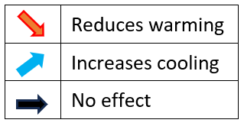
Table 3
Radiative forcing component | Effect of Climate Photocatalyst
CH₄ (Methane)
Organic Halogens
Tropospheric Ozone
Stratospheric Water Vapour
Light absorbing particles on snow and ice
Aerosol - cloud
Aerosol - radiation (haze?)
CO₂
N₂O (Nitrous Oxide)
Albedo - Land Use
Contrails & Aviation-induced cirrus

We expect diffuse ocean iron fertilisation by sedimented Climate Photocatalyst particles with an iron component to absorb atmospheric CO₂ (and/or reduce ocean CO₂ outgassing) but since estimating the magnitude and duration of that effect requires more research it is not considered in this paper.

Illustration of Climate Photocatalyst reducing radiative forcing.
The IPCC data from Figure 1 are repeated below in Figure 9 as a waterfall chart. Red/blue columns respectively indicate warming/cooling. The beige-green column shows the resulting global Effective Radiative Forcing. The darker colors show the forcing components addressed by Climate Photocatalyst. Light pastel shaded colors show warming/cooling influences that are unchanged by Climate Photocatalyst, mainly CO₂.
Earth’s Energy Imbalance (EEI) is a measure of the overall energy flux (power) that is warming the climate still further. In 2023 EEI was calculated at around 1.32 W/m² (Hansen 2023b). How is this possible given that Effective radiative forcing was around 2.9 W/m²? Given that the Earth’s average surface temperature has increased, it now naturally radiates more longwave energy out to space than preindustrially, which represents a negative forcing. In 2022 this energy flux, indicated by the orange line in Figure 9 below, was around 1.58 W/m² (2.90 - 1.32 = 1.58).
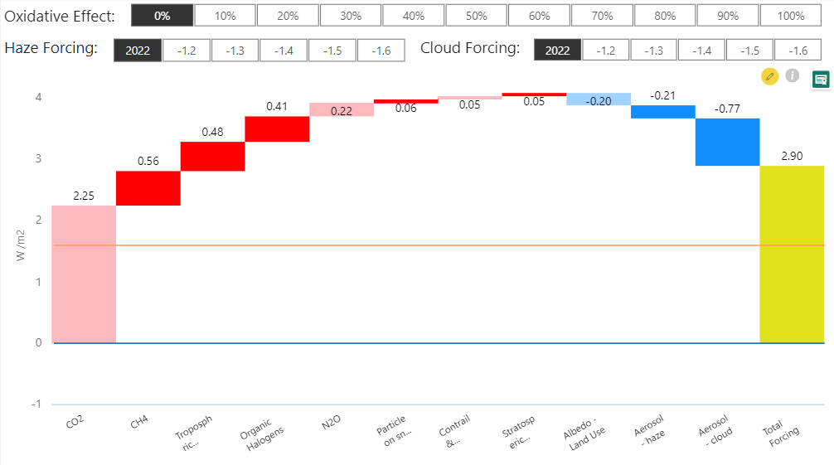
Energy imbalance of 1.32 W/m² induces continued warming.
The additional longwave energy flux returning to space in 2022 from warmed Earth was around 1.58 W/m².
Figure 9 – In 2022 the Effective radiative forcing was 2.9 W/m² above preindustrial.

In the scenario of Figure 10 below, the warming influences addressed by Climate Photocatalyst are reduced by 60%. Haze cooling has been increased to 1.6 W/m². Cloud cooling has also been increased to 1.6 W/m². The effect would be a reversal of the current warming trend to a cooling trend. That is because Earth’s energy imbalance is reduced from 1.32 to around -1.84 W/m².
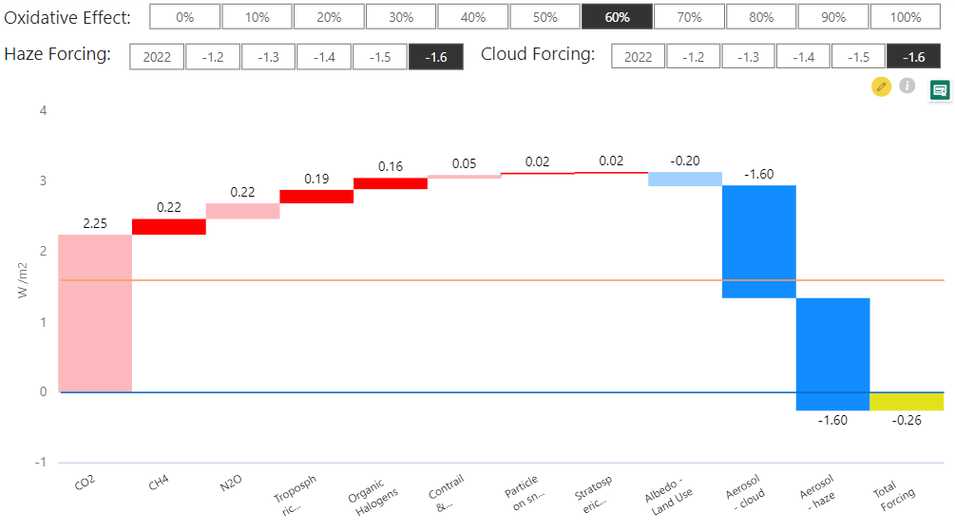
Warming influences reduced by 60%.
Cooling influences increased.
Negative energy imbalance of -1.84 W/m² induces cooling.
Effective forcing of -0.26 W/m² is less than preindustrial.
Figure 10 – Effective radiative forcing reduced to -0.26 W/m² below preindustrial.

Ice sheet collapse avoided?
If the Effective radiative forcing of -0.26 W/m² shown in Figure 10 were to be maintained, the global average temperature would in theory eventually cool below pre-industrial temperature. However, whether such cooling magnitude would be sufficient to prevent eventual collapse of the polar ice sheets would require further work by glaciologists. That is because ice sheet melting and subsequent refreezing exhibit hysteresis. In other words, the point of no return becomes the point of return only if the temperature can be reduced significantly below the temperature at which the ice sheet melted.
Without doubt glaciologists would say that the longer these ice sheets are allowed to melt, the colder the eventual global temperature would need to be to prevent them collapsing. However, shielding the ice sheets from direct sunlight during summer months using an aerosol haze would help (see p33). Such a combined intervention to prevent runaway ice sheet collapse in time to avoid an AMOC collapse should avoid the feared boulder-lifting superstorms of past eras.

Best locations to disperse the aerosol.
Maximising the effectiveness of Climate Photocatalyst by dispersing it in optimal locations as described above means less aerosol needs to be dispersed to achieve the same effect, reducing the overall cost. Meteorologists advise that the safest, most effective way to cool the polar regions without causing sharp temperature gradients would be to reduce the temperature of air and water flowing into them from lower latitudes. As mentioned in the Background section, given that heat flows from low latitudes to high latitudes, an intervention to cool low latitudes would propagate a cooling effect into high latitudes. In other words, cooler, drier air, and cooler tropical waters would feed through to further cool the remaining ocean areas, including the polar regions.
Three more arguments can be made for focusing cooling at low latitudes:
- Reducing the warming amplification by water vapour at its most severe location would tend to feed lower amplification into higher latitudes, representing the most efficient cooling effort.
- Cloud fraction is lowest in low latitudes, typically around 40%, which makes the 60% clear skies of the tropical and subtropical oceans the most effective locations to disperse Climate Photocatalyst for haze cooling. The direct aerosol effect (haze reflectivity) is negligible in subtropical stratocumulus regions (Ahlm 2017).
- UV intensity is much higher in the tropics (Ref papers coming from Franz), making removal of SLCFs most optimal at these latitudes.

For cloud brightening, the best locations are the East coasts of North and South America (Jones and Haywood; *others).

Transforming self-reinforced warming to self-reinforced cooling
The current rapid warming exacerbated by SO₂ pollution removal has upset the balance of numerous Earth systems. This includes lost: phytoplankton productivity, marine acidic aerosol concentration affecting natural ISA methane removal, and cloud albedo. Climate Photocatalyst can help restore that balance.
Increasing the albedo of clouds and ice would add the additional benefit of increasing natural removal of SLCFs. That is because UV is efficiently back-reflected by bright clouds and ice. This back reflection adds a further path for UV to induce photochemical emission of ºOH radicals, thereby further increasing the overall natural oxidative capacity of the troposphere. That further increases the removal rate of SLCFs, helping to further reduce their lifetimes and associated radiative forcings, in two virtuous self-reinforcing mechanisms driven by cooling. The first one help us to restore more polar and mountain ice. In in the second mechanism cooler ocean surfaces exhibit higher primary productivity of phytoplankton, increasing cloud fraction (apparently, p18). That is because nutrient mixing is increased in cooler surface waters because there is less stratification induced by ocean layer density differences.
The diffuse addition of iron to large areas of ocean would accelerate restoration of phytoplankton growth, quickly restoring natural acid levels in the marine boundary layer. (Ferric iron becomes bioavailable when it gets ‘complexed’ by ocean microbes.)

Dispersal techniques and platforms
Dispersal of Climate Photocatalyst aerosols could be carried out from almost any platform, including autonomous boats or buoys, existing ships, UAVs (mid to large sized drones), and fixed or mobile land-based facilities. UAVs could be used to brighten cloud tops, with early experimentation helping to optimise the process. Use of mobile platforms such as UAVs and marine vessels means cooling effects can be maximised, and weather patterns optimised. That is because dispersal location could be controlled by meteorologists in near real time. Modern forecasting techniques and AI would be able to optimise the process (Ref Gadian).

Self-positioning dispersal buoys
Mass produced Self-Positioning Dispersal Buoys (SPDBs) placed several km apart in lines perpendicular to the direction of the trade winds would provide a low-cost method of increasing haze/cloud cover over large areas of tropical ocean. This would provide cooling similar to that recently lost from shipping, mainly in the northern temperate zone since shipping pollution controls came into force. A long line of haze/clouds would form in the wind from each device, resembling former ship tracks.
Self-positioning marine devices are already under development by MIT (Ref) named SCOUT ASC (Autonomous Surface Craft), for collecting and transmitting environmental data. SPDBs could use the same open-source communication protocol (DTN – Delay Tolerant Networking) from the Internet Engineering Task Force (IETF), which is planned for communication with satellites or to and from service ships. SPDBs could also use the same Automated Identification System (AIS) used by SCOUT ASC transponders, which is required for marine vessels. (SPDBs should be located far from busy shipping lanes.)
Such communication would enable remote control of dispersal operations by a designated meteorological control centre. Status reporting should also be provided, to enable timely maintenance and recharging of SPDBs by service ships. SPDBs may be designed to operate for several years between maintenance recharges, keeping operational costs low. Before recharging, the SPDBs could be gathered up into groups, enabling more to be picked up and exchanged with refurbished replacements during each stop. Recovered SPDBs could be recharged onboard or taken ashore if necessary.
The chloride vapours could be produced inside each SPDB from the liquid feedstocks (SiCl₄, TiCl₄, etc.) by bubbling dry air through them from a compressed air source. A battery and renewables could provide the energy to sublimate the solid anhydrous chloride substances (AlCl₃, FeCl₃). A thick fog would emanate from the emission source of each SPDB, which would rise and spread in the air as a haze, before later forming or brightening clouds.
An array of SPDBs would be fault tolerant. If some of them develop faults the central control system could adjust the others to compensate, to provide roughly the same amount of cooling. There would be little discernible difference overall given that the weather varies so much anyway. Weather forecasting models could then be adjusted to the actual cloud cover provided. Such adjustment would itself be needed anyway given the variability in each grid cell of wind speed and direction, and other meteorological factors.

Raising the aerosol above cloud level
[review/improve] Turbulent tropospheric air would carry at least some of the aerosol up to cloud level, as already occurs naturally for existing aerosols and their precursor substances. However, lifting the aerosol above cloud level where the air is drier its haze would remove SLCFs for longer, therefore requiring less of it to be dispersed, saving costs. Addition of Climate Photocatalyst to ships flues would enable the hot flue gases to carry the aerosol up several hundred metres.
An existing shipping company is currently in negotiations to include a Climate Photocatalyst aerosol in their flue gases (Ref BDC) [check with David HW]. That would remove some of their engine BC pollutants after emission, using engine NOx pollution as part of that removal process.
Ships could additionally be modified to propel the aerosol up above cloud level (around a 1 km above sea level), removing more SLCFs. Such modifications could include redirection of waste engine heat disposal from the sea to an air stream beside the flue gases to further help the aerosol to rise. Other possible modifications to help raise the aerosol include use of the rising air vortex principle (tornado effect) and/or giant air cannons. If effective, these methods would also be suitable for land-based facilities.

Ocean plastic cleanup with Iron-catalyzed complete combustion
An estimated 12.7 million tonnes of plastic is dumped in the oceans annually, equivalent to one garbage truck every minute. To help avoid the extensive damage of plastic pollution to ocean wildlife, another option could be to use ferric chloride as a combustion catalyst in incinerators with enhanced ventilation to fully combust waste plastic at sea. The hot flue gases would then be propelled up above cloud level, creating a long-lived haze that cools the ocean, with the iron chloride content photo-catalysing removal of SLCFs. Far out at sea the catalyst and fly ash would pose negligible threat to population centres. Further, it would help to nucleate clouds with the rainout adding nutrients to the ocean, mimicking volcanic ash. To reduce costs, the ferric chloride catalyst could be generated at sea by combusting scrap iron in chlorine electrolysed from seawater.
The CO₂ produced by the plastic combustion would at least in part be absorbed back into the ocean by the combined effects of:
- Ocean cooling (or at least decelerated warming) by:
  - Cloud cooling
  - Methane removal
- Alkalinity addition by seawater electrolysis
- Diffuse ocean fertilisation by sedimented iron-rich catalyst particles.
Another possible dispersal option involves land-based facilities to fully combust municipal waste similarly using ferric chloride aerosol particles as a combustion catalyst. The flue gases would similarly draw moist air up to form clouds high above the facility. In some coastal locations this could deliver rainwater inland. In rural areas it would not be necessary to remove fly ash from the flue gases, as the sedimented ash would improve soil fertility, much as volcanic ash does in volcanic regions of the world. If it proves safe and effective, this type of plastic incineration could be incentivised by methane removal credits, and perhaps even cloud cooling credits if enacted.

Targeted use cases
Climate Photocatalyst could be targeted for numerous possible additional uses. For example, it could be used:
During summer months in polar regions to:
- Shield melting ice from direct sunlight, using UAVs,
- Remove methane bursts from shallow Arctic Seas.
All year to:
- Reduce wildfire intensity and spreading speed,
- Reduce the severity of hurricanes and floods,
- Protect and enable coral reef recovery, which is important for fisheries, and (we can deduce) coastal cloud formation,
- Reduce emissions of black carbon aerosol into the air. That would:
  - Reduce its warming influence,
  - Slow down the accelerating rate of ice sheet melting, from ice-blackening,
  - Further protect the stratospheric ozone layer (see p37).

Preserving ice sheets
The slow refreezing of polar and mountain ice sheets from global ocean cooling could be aided by shielding them from direct sunlight during summer melting seasons to reduce melt rates. Haze and brightened clouds applied during summer months would help preserve winter snowfalls during polar summers (see Figure 11 below).
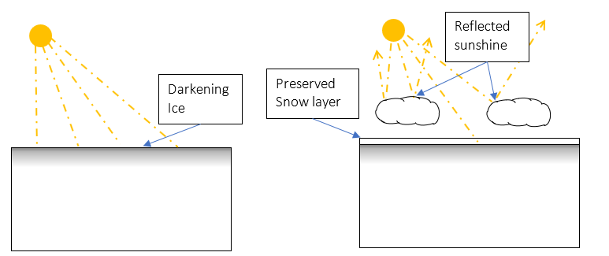
Figure 11 - Protecting ice during summer months

Delaying the onset of the accelerating summer melting phase could significantly reduce the ice loss, which is getting faster each year during peak melting seasons. Peter Wadhams (Emeritus Prof Ocean Physics, Cambridge) and Herbert Huppert (Prof Theoretical Geophysics, University of Cambridge) have suggested that sufficiently large-scale, expert use of such a technique might even be able to refreeze the whole Arctic.
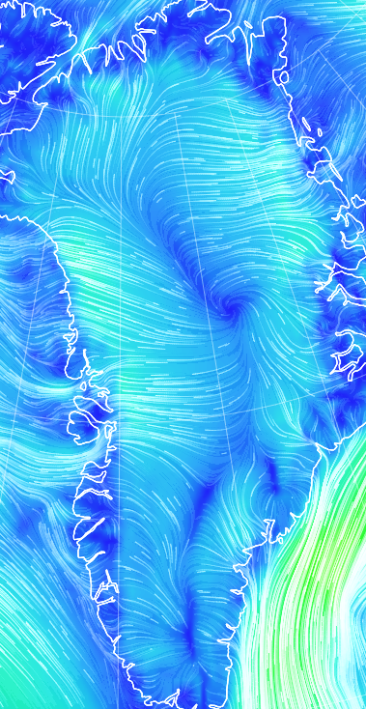
The cost of adding a cooling haze to ice sheets by UAVs could be minimised by taking advantage of wind forecasts. Winds over polar ice sheets tend to be katabatic, meaning they mainly blow down from the higher troposphere and then from the centre outwards (see Figure 12).
With this katabatic wind pattern, the addition of haze each side of the line would reduce cost.

Figure 12 - Greenland katabatic winds blowing outwards from the centre.

Dispersing the aerosol upwind (usually near the peak) would maximise the area cooled by the haze. When the haze eventually blows over the coastline the rising air from the warmer sea surface would produce cooling clouds that then shield direct sunlight from the polar seas, helping to shield them from the sun as well.
However, without a global ocean cooling intervention the window for refreezing polar ice sheets this way will close when the amount of heat flowing into them from lower latitudes overwhelms any possible summer preservation.

Removing Arctic methane bursts.
If a large Arctic methane burst were to occur, an iron free formulation of Climate Photocatalyst could be dispersed upwind to remove a substantial amount of it. The highly photosensitive nitrate and titanium peroxo content of Climate Photocatalyst is designed to produce abundant oxidative radicals even in the low light conditions of the Arctic.
Tests would determine the effectiveness of a non-iron formulation at producing oxidative radicals in the low light conditions of the polar regions. In any case, the aerosol could only operate for around six months of the year close to these potential methane bursts. That is because polar regions are too dark for half the year for any useful level of photochemistry to occur.

Ice sheets need an iron free aerosol.
If an aerosol were dispersed in polar regions or near mountain glaciers with an iron content, the particles sedimented on the ice sheets would fertilise growth of algae and biofilms. That would darken the ice, accelerating ice melt rates further. Therefore, any removal of Arctic methane bursts or sun shielding would need to be carried out using a variant of Climate Photocatalyst that contains no iron.

Reducing hurricane and flood severities
A global ocean cooling program would by itself tend to restore weather patterns. Even preindustrially, this included the occasional extreme event, but meteorologists may be able to curtail the severity of any weather event with Climate Photocatalyst (and/or other aerosols) if an internationally integrated dispersal control regime can be agreed. For example, with the help of AI it may be possible to disperse the aerosol in the right places at the right times to reduce the blocking effects that cause heavy flooding events from ‘atmospheric rivers’. It may also be possible to reduce the ‘Indian dipole’ that in recent years began disturbing monsoon rain patterns over the Indian subcontinent (Ref).
It has been suggested that white clouds formed from a high density of aerosol particles produce excessively heavy rain when they do eventually rainout. The addition of haze to large cloud-free areas of ocean may produce the needed cooling magnitude, with less need to brighten clouds that later produce heavy rain.
Directly cooling the ocean surface would help to reduce hurricane intensities. A novel mechanism could be of initiating waterspouts could achieve that effect, providing employment opportunities for trained locals. Climate Photocatalyst dispersed in the waterspouts should make it easier to get them started. Hundreds of temporary waterspouts would pose less danger overall than a severe hurricane.

Reducing wildfire intensities
A recent study on the increase of extreme wildfires in California concluded that the main cause is ‘fuel aridity’ (Ref Patrick Brown). Climate Photocatalyst haze could be used to keep areas at risk of wildfire moist before the fire season arrives. We would recommend its use as part of forestry management procedures to help reduce wildfire intensity and spreading speed.
Such aerosol dispersal would both remove atmospheric methane directly, and later have the effect of reducing methane emissions by avoided fires (Ref).

Removing black carbon aerosol (BC) from the air.
Increasingly, flue stacks employ equipment to filter out BC. However, wildfires, agricultural waste burning, and natural gas flaring remain major sources of BC. The best way to reduce these sources would be for them not to happen in the first place. BC from gas flares could be dramatically reduced by improving flaring equipment to combust the gas more fully. Alternatively, the gas could be fed to nitrogen fixing microbes, to produce environmentally friendly fertiliser (Ref). However, where these sources of BC exist, Climate Photocatalyst dispersed upwind of them would shorten particle lifetime in the air, reducing the climate warming effect. That is because the oxidative radicals provided by Climate Photocatalyst speed up the rainout of smoke particles (see p15).

When clouds ‘burn off’ (evaporate into the air), their water vapour warms the air by absorbing heat from the sun. Another indirect effect of BC is it increases the rate of ‘cloud burn-off’. Reduced and/or lightened BC particles mean cloud burn-off is reduced, keeping clouds cooling for longer.

Protecting coral reefs
Put in Tom Goreau’s map of coral reef risk. https://www.globalcoral.org/deadly-coral-bleaching-heat-wave-spreads-across-entire-caribbean/
[* how much of the Great Barrier Reef has been lost?]
Coral reefs may also be prolific producers of DMS (Ref) adding to coastal cloud albedo. That can be expected to decline with this year’s mass die off of tropical coral reefs..
The Great Barrier Reef has attracted significant funding and mainly positive public sentiment.

[Electrolyse chlorine from seawater, leaving basic (alkaline) seawater behind. This ensures no net acidity is added to the ocean, no matter how much FeCl₃ is added into the air. The Fe component would boost phytoplankton growth, thereby reducing surface acidification and ocean CO₂ outgassing.
Use of a jet engine on each ship to propel the aerosol 1000 m into the air would significantly reduce the amount of feedstock needed. The catalytic effect of the aerosol would quickly remove most of the black carbon aerosol produced with such a technique.
[If the cloud burns off it depletes methane from the atmosphere.]

Safety
Adding more clouds represents a small change of ‘signal’ to a large ‘noise’, the noise being the weather. If Climate Photocatalyst needs to be stopped for any reason, it gets rained out of the air within a few days to weeks. At that point it no longer has any effect on the climate.
While active in the air, Climate Photocatalyst would likely alter weather patterns, therefore large dispersal operations need careful planning by meteorologists. It should ideally be dispersed when/where it is needed in a way that optimizes weather patterns across the globe overall. Such a program would doubtless be controversial if intended to operate in the long-term, and would need to be managed transparently by a trusted intergovernmental body of experienced meteorologists and climate scientists.
Mention human rights.
Amorphous silica is an important nutrient needed by diatoms. Titanium improves ferric iron complexing and subsequent absorption by phytoplankton [check].
[Weigh risk vs risk of inaction or risks associated with other climate interventions.]
If small trials prove its safety, its dispersal could be increased further to provide the required magnitude of cooling.

Protecting the stratospheric ozone layer.
Naturally occurring oxidable halogenated gases such as chloro methane-are efficiently collected by black carbon aerosol as are other naturally occurring halogenated gases methyl bromide, methyl iodide. (BC operates like the activated carbon in air filters). Small amount of warming. Bromine and iodine are much stronger ozone destroyers than chlorine. Mainly, the presence of these gases strengthens the case for removing BC aerosol, which shuttles them up to destroy the stratospheric ozone layer.
Climate Photocatalyst also lightens the color of BC particles, which slows down their ascent to high altitude. In this way Climate Photocatalyst also helps to protect the ozone layer by preventing smoke particles that adsorb halogenated gases and other ozone destroyers from entering the stratosphere, where it releases them (ref Solomon).
Climate Photocatalyst particles themselves do not reach the stratosphere because the water they absorb makes them either rain out or become ‘frozen out’ before they reach the tropopause. This is the same behaviour as all other hygroscopic aerosols (Ref TOA particles do not reach the stratosphere).

Toxicology
Titanium oxide is low in toxicity. It is used as a paint whitener, in sun creams, and has been used as a food additive for farm animals for years. [Ref appendix of toxicology tables]. When spreading in the air at a density of 200 particles/cm³ the mass of particles is X mg/m³. That is % of the amount allowed to be breathed in all day in workplaces (OHSA). However, we do not recommend dispersal near urban areas unless its purpose is to help clean up the kind of very heavily polluted air found in some developing countries.
When Climate Photocatalyst aerosol particles sediment in raindrops its pH is above 5 (i.e. less acidic than a bottle of carbonated water). At that pH it flocculates to form a loose sticky gel that sticks to others suspended material, eventually transforming to become clay mineral, which is completely inert.

Comparison to Stratospheric Aerosol Injection (SAI)
[Improve section] Climate Photocatalyst mimics natural environmental processes that have occurred continuously for billions of years. By contrast, SAI mimics a process that occurs only sporadically in nature, namely intense volcanic activity. Such activity reduces the UV intensity emerging from the stratosphere, which alters the photochemistry of the troposphere for several years, after which tropospheric processes then recover. Mimicking continual volcanic activity over decades would alter tropospheric processes in profound ways as described below.
It takes several years for SAI particles to leave the stratosphere, during which time the dimmed level of light weakens the tropospheric photochemistry that cleans the air of powerful greenhouse gases such as methane (Ref Banda). Therefore, methane levels can be expected to increase faster during an artificial SAI intervention. In nature, tropospheric photochemistry recovers to full-strength as soon as the material injected into the stratosphere clears. Mainly it clears by descending in polar regions, increasing cloud cover, thereby blocking loss of heat to space during polar winters. In contrast, clouds in the troposphere have continuously cooled the Earth for billions of years,
SAI would weaken the methane sink (Madronich), leading to increased concentration of SLCFs such as methane. This would then require an even greater SAI effort in a spiral that could profoundly alter Earth’s atmospheric conditions. It would be safer to make relatively small changes to the already very variable weather. An SAI programme lasting for decades or hundreds of years would mimic long-term intense volcanic activity. That is unusual in Earth’s recent history and would represent an even more profound change to its atmosphere than today’s pollution and increased greenhouse gases.
The addition of iron rich mineral dust into the troposphere by the 1991 Pinatubo eruption would have offset the loss of UV, by the addition of mineral dust in troposphere photo catalysing methane removal and diffusely fertilising large areas of ocean. However, SAI proposals include no such offsetting mechanism.

Weakened methane sink from an SAI intervention.
An SAI intervention would weaken the naturally occurring sinks. More work is needed to determine by how much a loss of UV would extend the lifetimes of SLCFs and pollutants in general, and by how much of their existing concentrations would increase.
However, if an SAI intervention does get enacted, a concomitant Climate Photocatalyst intervention should still be able to make use of the lower UV levels, to compensate for the effects of SAI, reducing SLCFs levels. We suggest that a tropospheric only intervention would be safer, cheaper, and more beneficial overall, assuming it is used for peaceful purposes only.
The current SAI proposal (Nov ’23) is to begin by applying it only in polar summer months in latitudes above 60°N and below -60°S. Proponents argue that the aerosol would descend from the stratosphere in the fall, enabling heat loss as normal during the polar winters. If it works as hoped, then some valuable ice preservation may be achieved, protecting ocean circulation occurrence. However, only a small cooling effects can be expected at low latitudes because the flow of stratospheric air tends to move poleward (Brewer Dobson). This therefore does not solve the problem of low latitude warming. The danger is then of the SAI programme getting extended to cover the whole globe.

Costs.

Cost Summary
We expect the total annual cost of a full ocean cooling operation to be in the region of $1 – 5 billion / year.

An MCB illustration has been provided by Prof Stephen Salter to provide cooling of 1.8 W/m2 by introducing N x 10^{m} seawater particles into the marine boundary layer of the global oceans. Using the same Schwartz/Slingo equations we calculate N x 10^{m} particles are needed to extend the existing haze and cloud cooling by 2.2 W/m2. That is calculated from the haze and cloud cooling forcings taken from Figure 10 and Figure 9 as (1.6 + 1.6) – (0.21 + 0.77).

The spreadsheet below calculates the cost of the required feedstock chemicals to provide the same number of Climate Photocatalyst particles as MCB with sea spray in the region of $500 million per year. The cost per ton of chemical feedstock based on a 30% discount on retail prices. In practice, for the high volume needed, we would expect a cheaper cost, because most of the cost of retail products is for purification, which is not needed for the aerosol feedstock for dispersal over the ocean. Only dispersion near ice sheets needs a feedstock with impurities such as iron and manganese removed (see p35).

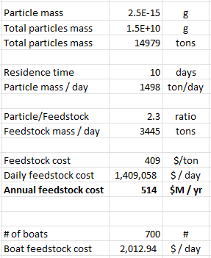
We expect additional costs to be at least another $500 million for:
- R&D,
- boats/ self-positioning buoys,
- fuel (unless all solar/wind powered),
- Operations and Management,
- PR
- etc.
Since oceangoing vessels can cost $50,000 per day to operate, the $500 million cost could quickly escalate.

Estimated material amounts from total required CCN
[Redo Excel Calc] [add a Calc from Ahlm if possible.] The quantity of vessels needed for an effective cooling program is taken from work carried out by the proponents of marine cloud brightening. That proposal suggests a fleet of about 700 special-purpose wind-driven catamarans, that spray a fine mist of seawater into the air (Ref). [Add Stephen Salter info.]

The additional energy reflected away by brightened clouds can be quantified by measuring cloud albedo (reflectivity). Equations developed by Schwartz and Slingo enable estimation of the concentration of CCN particles needed to provide a given cloud albedo (Ref). Measurement of cloud albedo enables resulting radiative forcing to be calculated.
Proponents of Marine Cloud Brightening (MCB) calculate that around an additional 10²³ [check] micron-sized aerosol particles need to be added to the marine boundary layer to stop the oceans warming and the ice sheets melting. This could be achieved with about 700 special-purpose wind powered boats. (Ref Salter)

Feedstock costs
The feedstock cost of a Climate Photocatalyst intervention to reduce the current radiative forcing of 3.2 W/m2 to 0 is conservatively estimated at around $500 million /year. That would involve the following:
- Cooling the oceans, to pre-industrial temperatures,
- Halving atmospheric methane level from 1.9 to under 1.0 ppm,
- Protecting ice sheets during summer months, to minimise melting by direct sunlight.
Put in:
- particle size, mass, and volume. Cost of precursors etc.
- Dispersal platforms

Cost of materials and fuel
Note: all these estimates are preliminary first approximations, based on a 30% bulk discount on the retail prices of precursor materials, and dollars/gallon of gasoline.
All feedstock precursors are already available at scale, at affordable cost.
[Get costs from Excel]

Cost of reducing wildfires
[Estimate a first order per hectare cost]

Business Model
If policymakers are serious about delaying or preventing catastrophic ice sheet collapse and superstorms, wildfires, loss of food and water security, loss of coral reefs and so forth, appropriate incentives need to be made available. Such incentives should include methane and black carbon removal credits, and ultimately cooling credits. All these activities could be measured and verified by satellite and appropriately placed ground/sea monitoring stations.

Next Steps.
Currently Climate Photocatalyst is a proposal looking for funding to be tested, first in laboratories to develop the safest, most effective formulation options, then field trialled to optimize cooling operations. If the trials are successful, we would request regulatory support from governments to ensure it is used in well-coordinated, peaceful, environmentally beneficial ways. Only then should it be scaled up to cool the world’s oceans and ice sheets. Even that should be done incrementally to ensure that the effects are always beneficial.
It is for policymakers to decide whether it is preferable to try to cap the millions of sources of short-lived warming agents (SLCFs) or, if an aerosol can be deployed to cool the oceans by increasing cloud albedo, whether that aerosol should embody a technology that also removes SLCFs from the air.

International political cooperation needed.
In addition, intergovernmental support will be needed, with an international framework agreed, and local indigenous groups involved and fully informed of both the potential benefits to them and risks of inaction.

Accurate satellite measurement needed.
The radiative forcing of aerosols is estimated with large error bars because no suitable satellite exists to measure the effect of aerosols on cloud physics accurately, despite the cost being moderate. A satellite launched with the required instruments would enable far better management of a cloud cooling program.

Further tests needed.
Description
Tests to determine the effectiveness of a non-iron formulation in the low light conditions of the polar regions.

Tests and development activities.
Date | Description | References
2014-2016 | Quantity of chlorine radicals emitted by several iron compounds under simulated sunlight conditions. | Wittmer & Zetzche
 | Modelling to test the effect on the existing methane sink of a homogenous increase of atmospheric Cl.
 | Field measurements of atmospheric methane removal by mineral dust in the marine boundary layer. | Van Herpen et al.
Planning stage | Salt pan test to measure oxidative radical emission rate by Climate Photocatalyst. | Copenhagen University
In progress | Marine cloud brightening seawater filtration and nozzle development | Centre for Climate Repair, Cambridge (UK)

Conclusion
If the Climate Photocatalyst can operate cost-effectively and at scale it will represent the ‘low-hanging fruit’ of climate action.

References
Forster. (2022). Indicators of Global Climate Change 2022: annual update of large-scale indicators of the state of the climate system and human influence. Earth System Science Data, 2305 (11). Retrieved from Earth System Science Data: https://essd.copernicus.org/articles/15/2295/2023/
Hansen, J. (2009). Storms of My Grandchildren. Bloomsbury.
Keigwin, L. e. (2018). Deglacial floods in the Beaufort Sea preceded Younger Dryas cooling.
Newman, N. (2023). The global costs of extreme weather that are attributable to climate change. Nature Communications, 1.

O’Gorman, P. A., and Caroline J. Muller. "How closely do changes in surface and column water vapor follow Clausius–Clapeyron scaling in climate change simulations?." Environmental Research Letters 5.2 (2010): 025207.

